Assignment 9

* Create a *StatefulWidget* that displays an image. The image should be centered on the screen. The image should change to another image when the user presses a button. You need to add five different images in the *assets* folder. When the user reaches the last image, the image should change back to the first image.

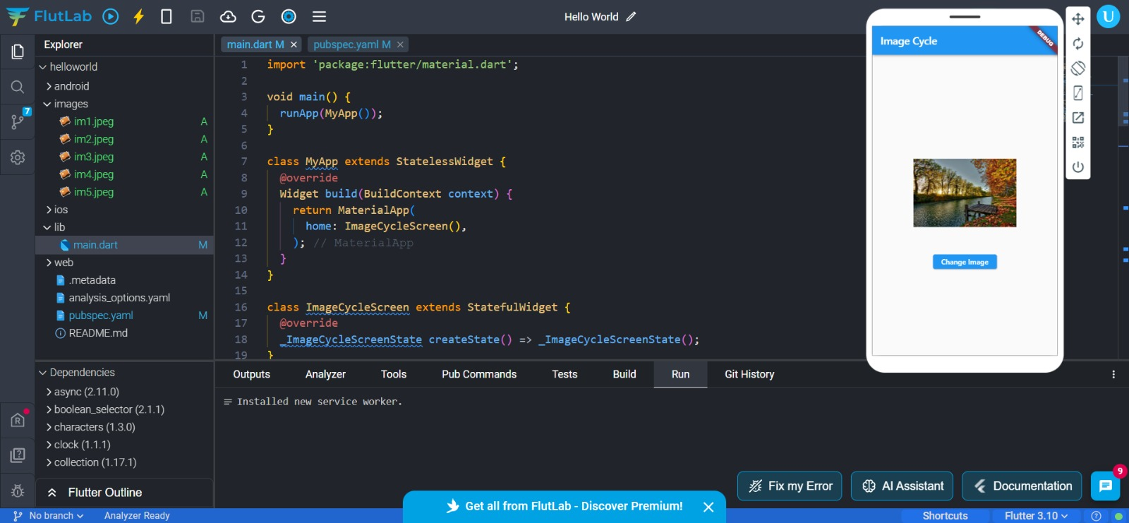

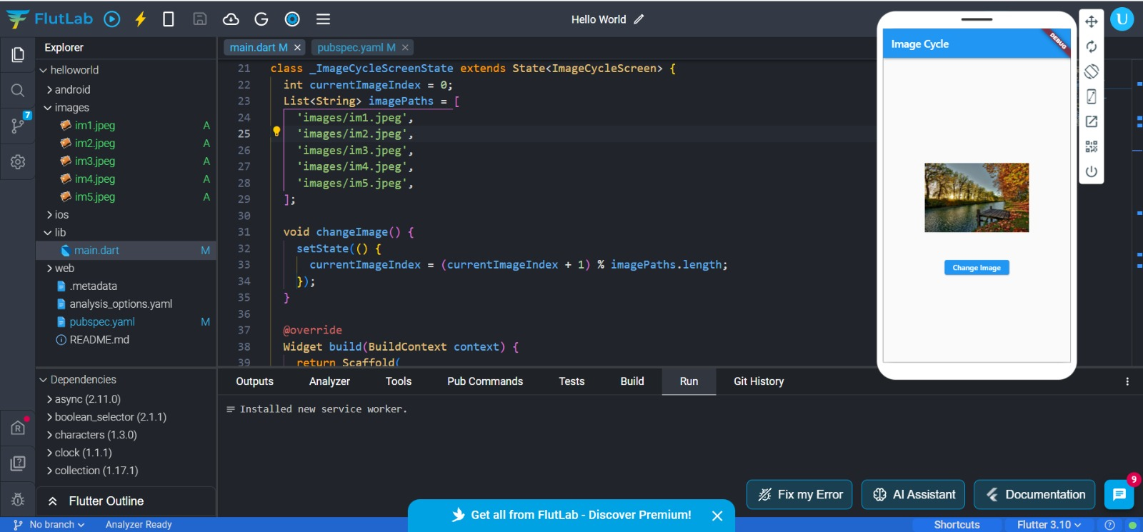

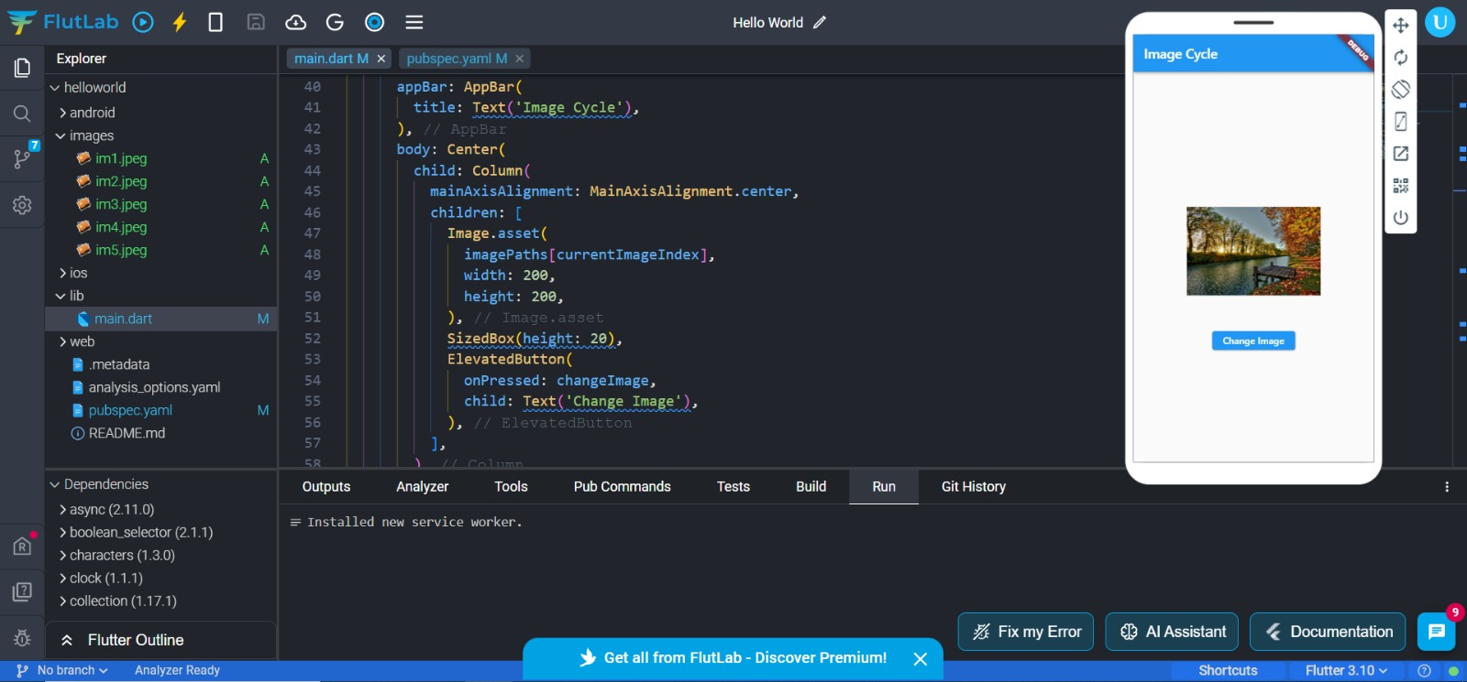

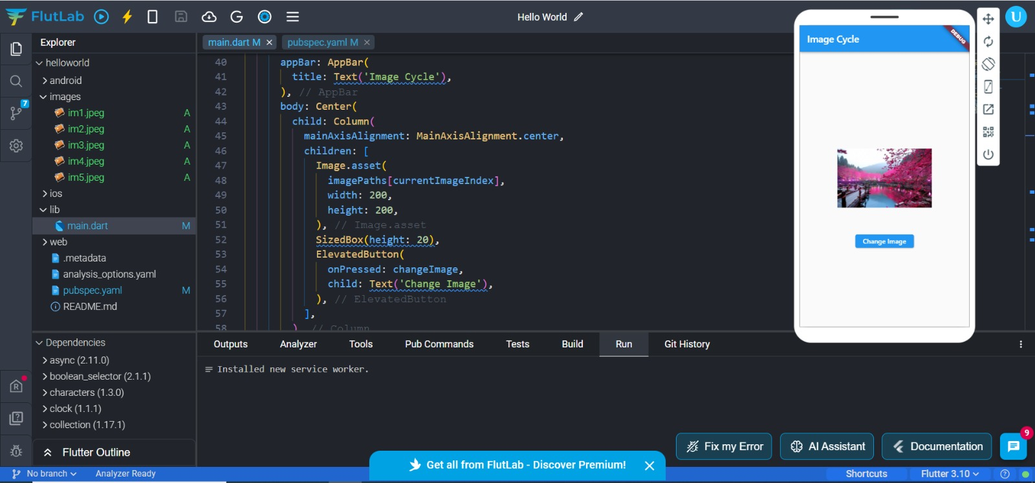

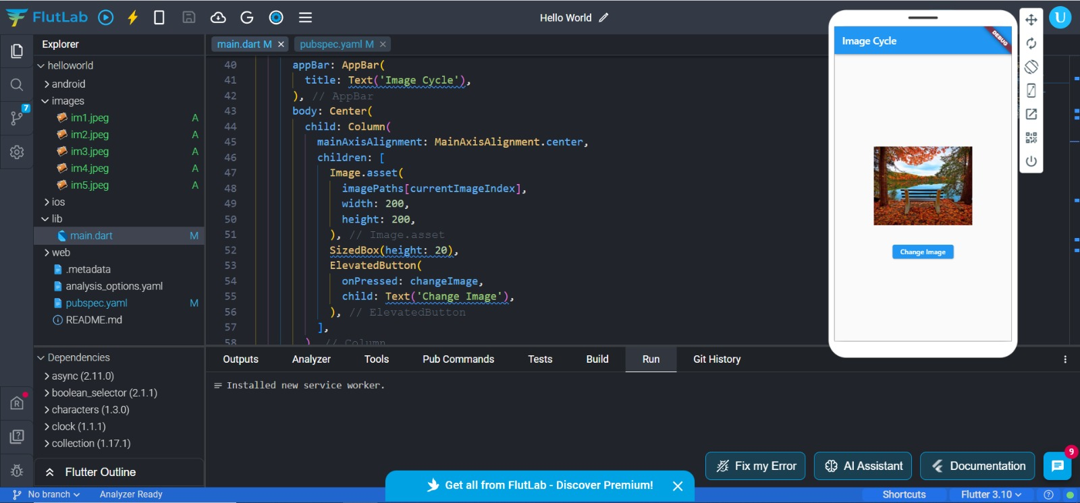

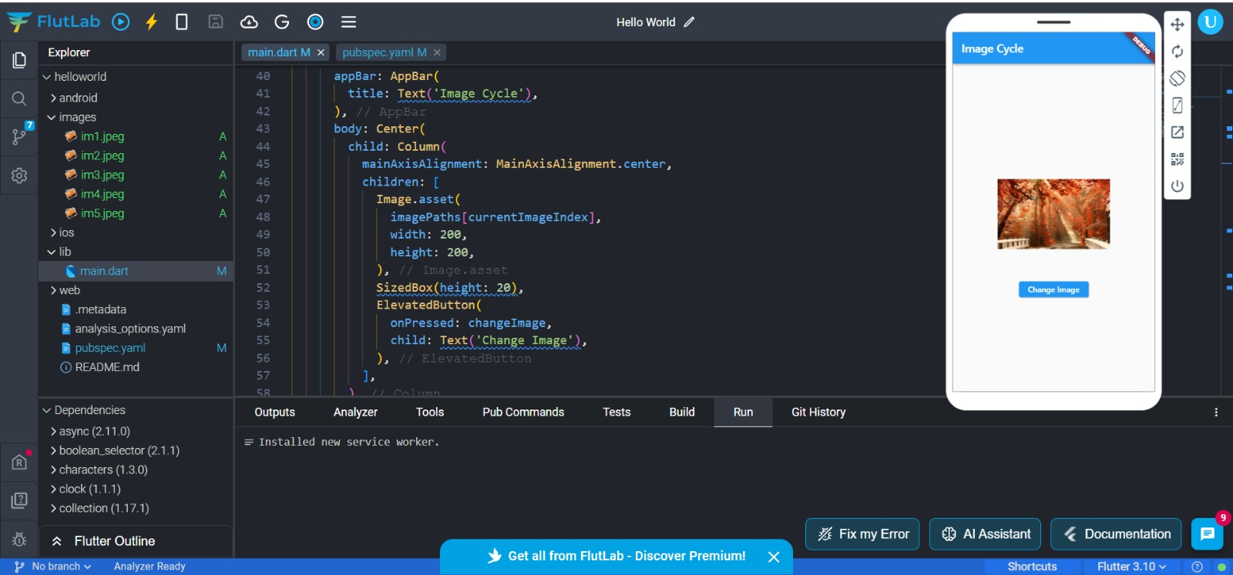

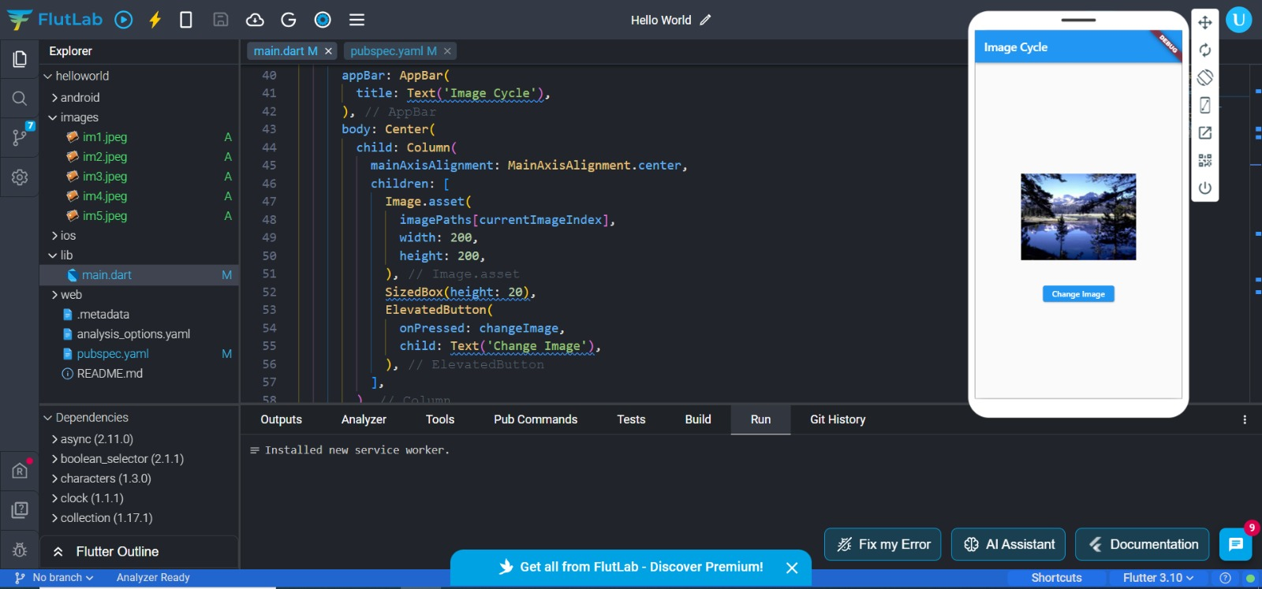

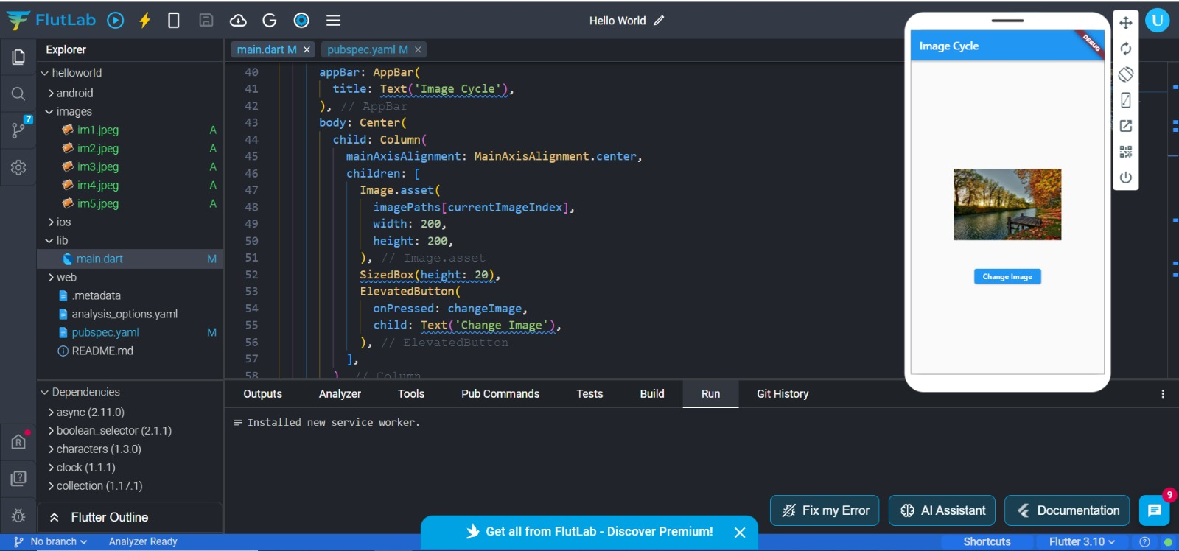

import 'package:flutter/material.dart';

void main() {

runApp(MyApp());

}

class MyApp extends StatelessWidget {

@override

Widget build(BuildContext context) {

return MaterialApp(

home: ImageCycleScreen(),

);

}

}

class ImageCycleScreen extends StatefulWidget {

@override

_ImageCycleScreenState createState() => _ImageCycleScreenState();

}

class _ImageCycleScreenState extends State<ImageCycleScreen> {

int currentImageIndex = 0;

List<String> imagePaths = [

'images/im1.jpeg',

'images/im2.jpeg',

'images/im3.jpeg',

'images/im4.jpeg',

'images/im5.jpeg',

];

void changeImage() {

setState(() {

currentImageIndex = (currentImageIndex + 1) % imagePaths.length;

});

}

@override

Widget build(BuildContext context) {

return Scaffold(

appBar: AppBar(

title: Text('Image Cycle'),

),

body: Center(

child: Column(

mainAxisAlignment: MainAxisAlignment.center,

children: [

Image.asset(

imagePaths[currentImageIndex],

width: 200,

height: 200,

),

SizedBox(height: 20),

ElevatedButton(

onPressed: changeImage,

child: Text('Change Image'),

),

],

),

),

);

}

}

* Reformat the code from the previous exercise to display the images in a random order. In other words, the images should be displayed in a random order every time the user presses the button.

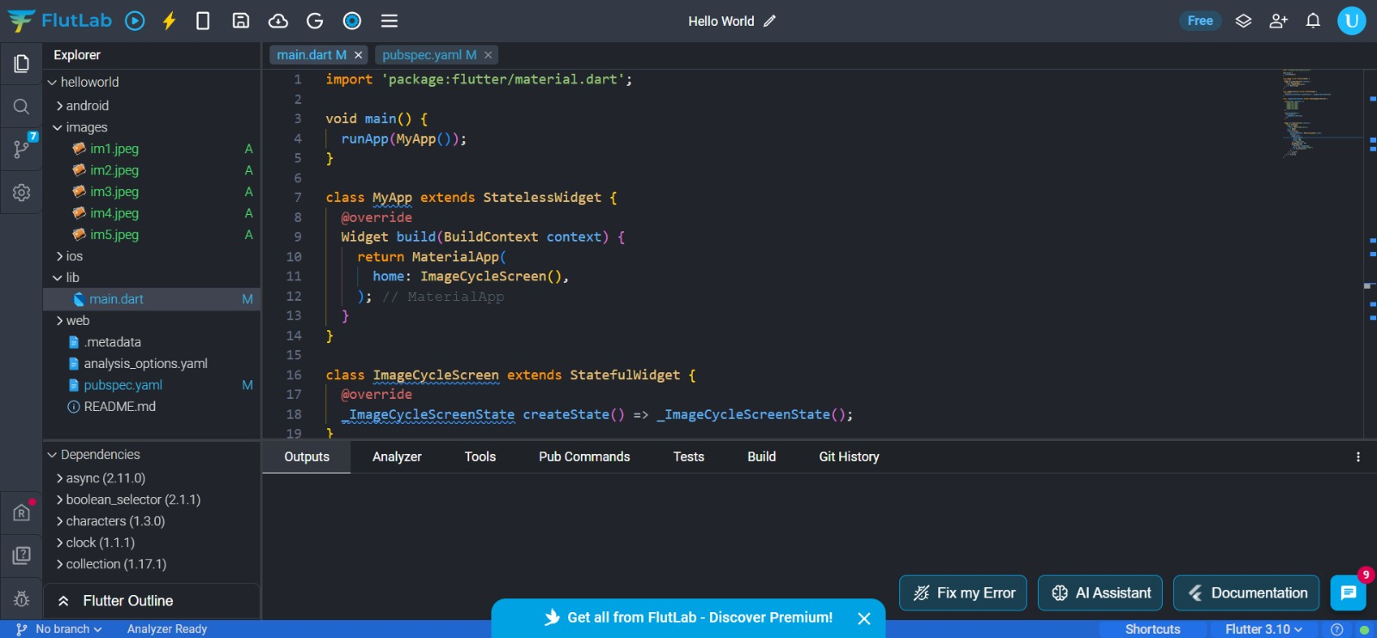

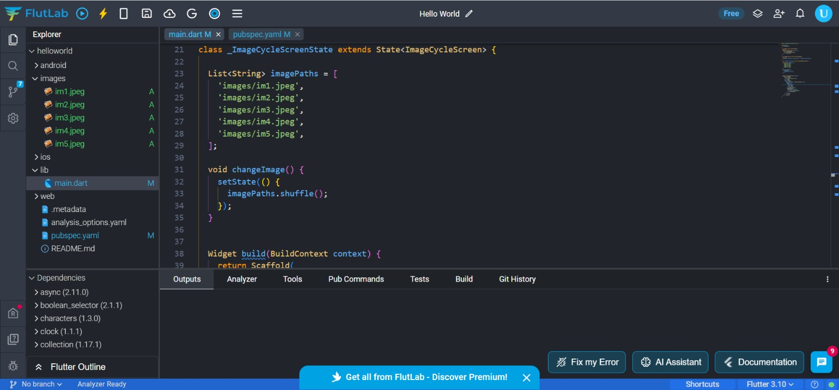

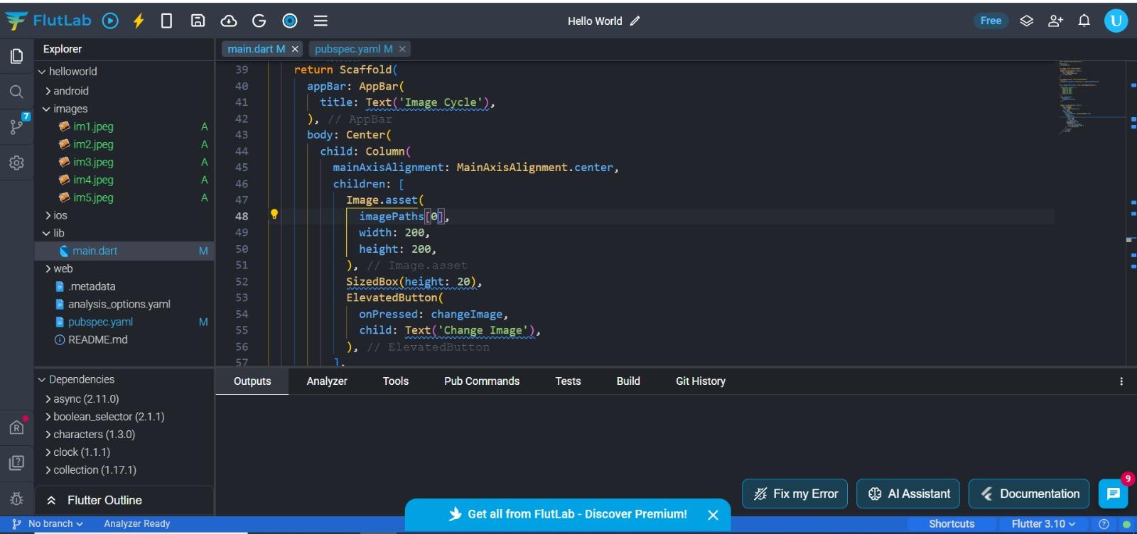

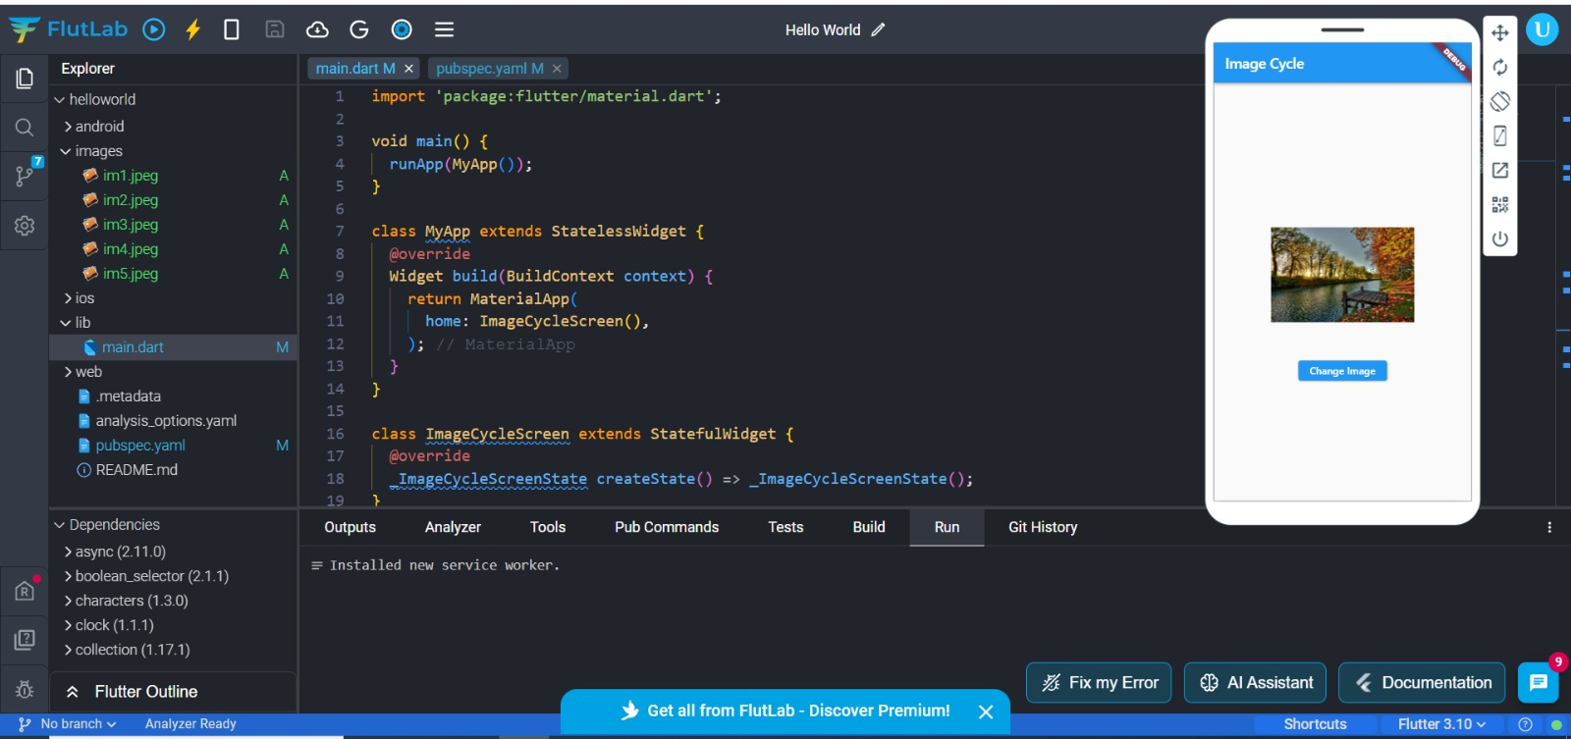

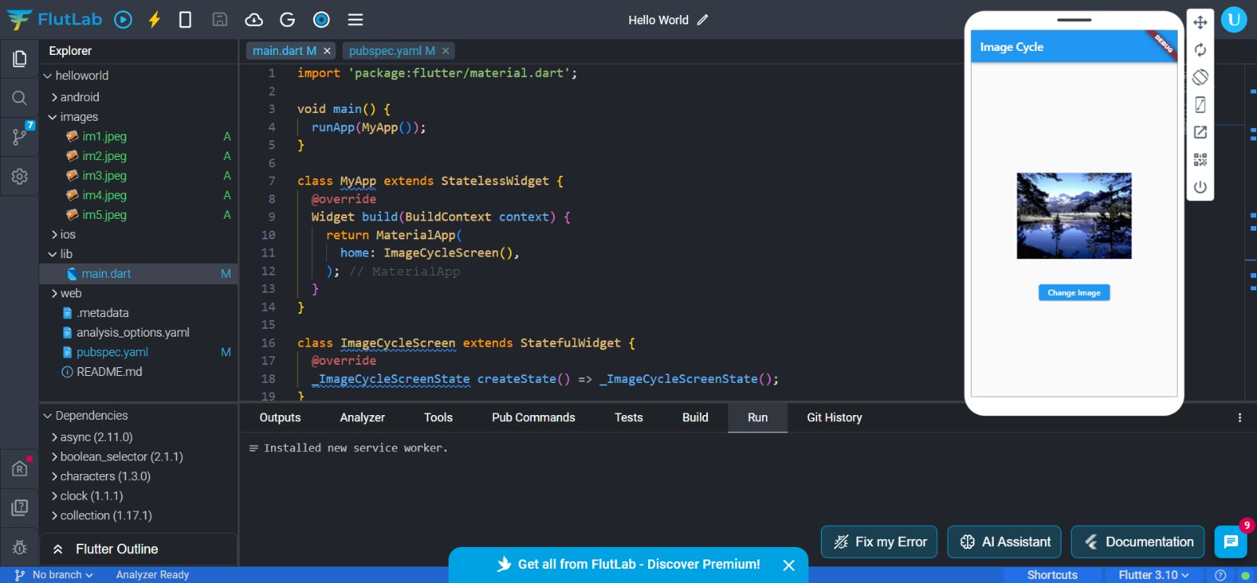

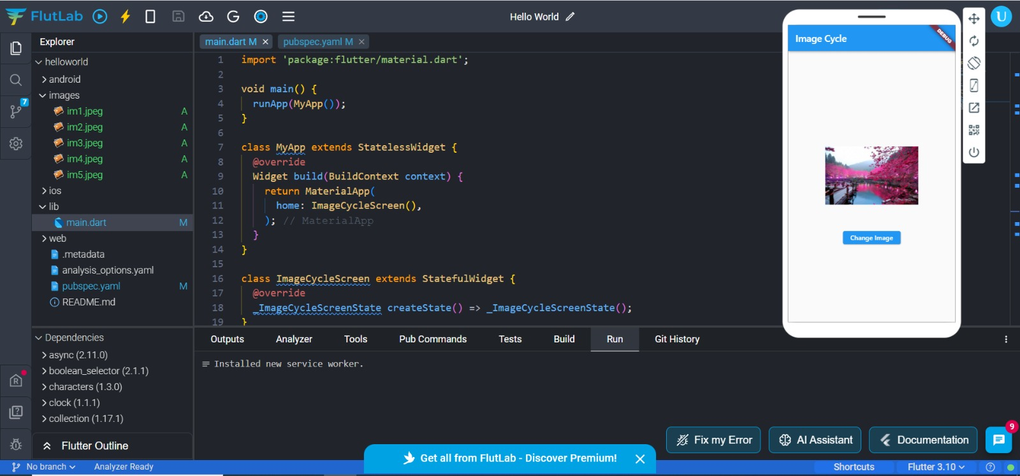

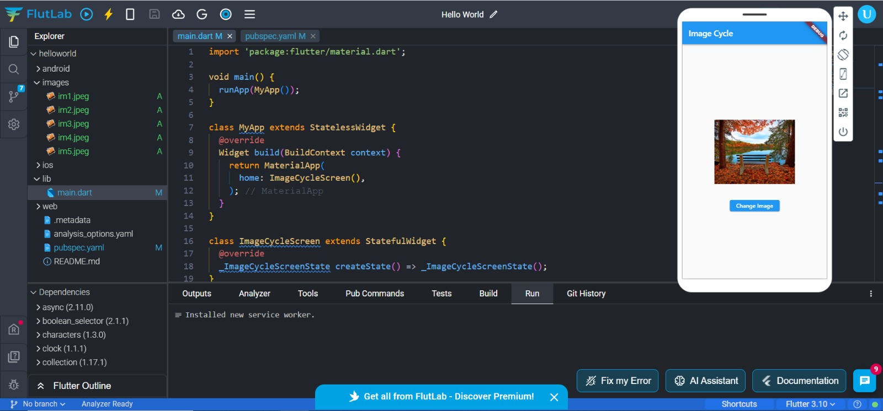

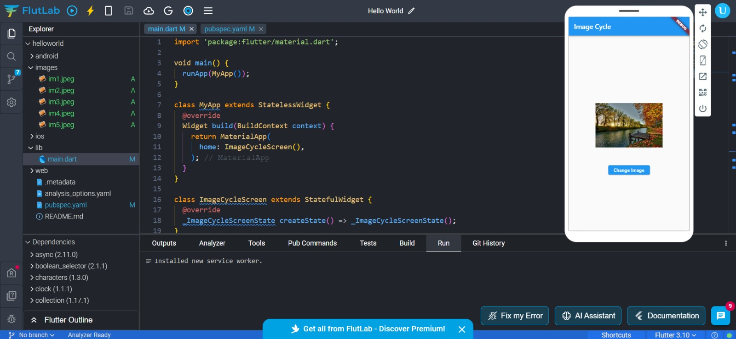

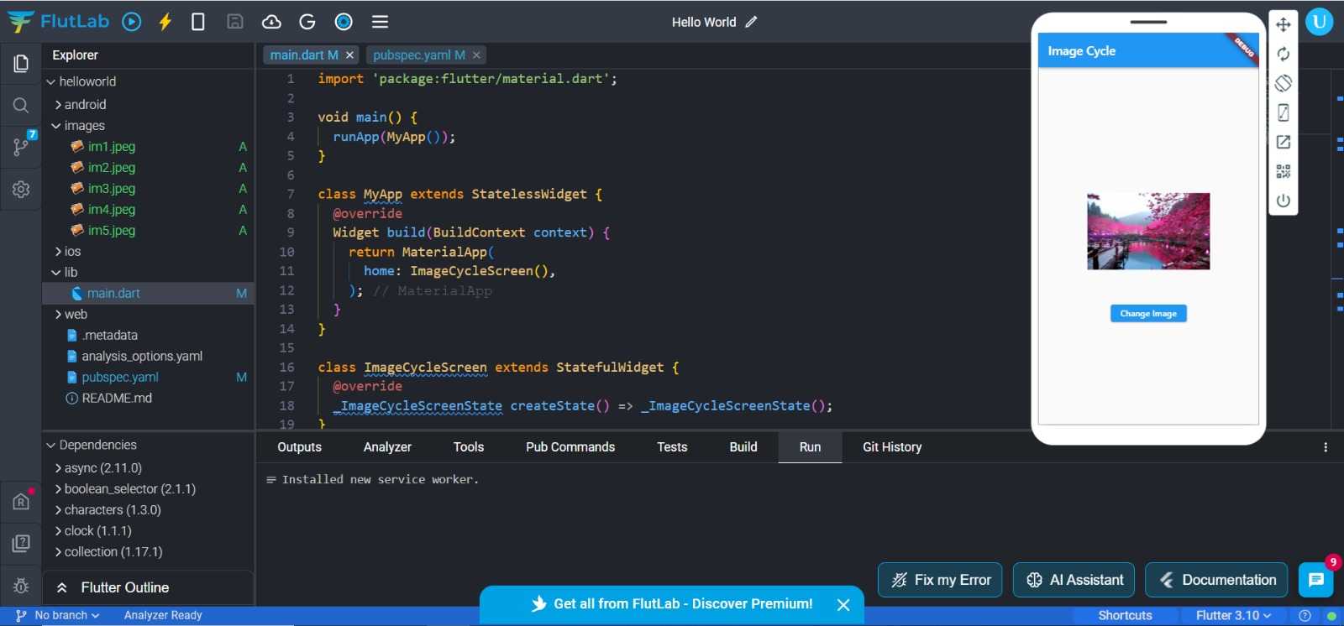

import 'package:flutter/material.dart';

void main() {

runApp(MyApp());

}

class MyApp extends StatelessWidget {

@override

Widget build(BuildContext context) {

return MaterialApp(

home: ImageCycleScreen(),

);

}

}

class ImageCycleScreen extends StatefulWidget {

@override

_ImageCycleScreenState createState() => _ImageCycleScreenState();

}

class _ImageCycleScreenState extends State<ImageCycleScreen> {

List<String> imagePaths = [

'images/im1.jpeg',

'images/im2.jpeg',

'images/im3.jpeg',

'images/im4.jpeg',

'images/im5.jpeg',

];

void changeImage() {

setState(() {

imagePaths.shuffle();

});

}

Widget build(BuildContext context) {

return Scaffold(

appBar: AppBar(

title: Text('Image Cycle'),

),

body: Center(

child: Column(

mainAxisAlignment: MainAxisAlignment.center,

children: [

Image.asset(

imagePaths[0],

width: 200,

height: 200,

),

SizedBox(height: 20),

ElevatedButton(

onPressed: changeImage,

child: Text('Change Image'),

),

],

),

),

);

}

}